**Interview Questions and Answers**

Q: **What is the CDS view?**

A: To take advantage of SAP HANA for application development, SAP introduced a new data modeling infrastructure known as core data services.

CDS is an enhancement of SQL which provides a Data Definition Language (DDL) for defining semantically rich database tables/views (CDS entities) and user-defined types in the database. Some of the enhancements are:

* Expressions used for calculations and queries in the data model
* Associations on a conceptual level, replacing joins with simple path expressions in queries
* Annotations to enrich the data models with additional (domain-specific) metadata

Q**: Explain CDS-related Repository Objects?**

A:

**Data Deﬁnition :**

Also referred to as DDL Source (for Data Deﬁnition Language, named after the DDL part of SQL)

Contains the deﬁnition of either a CDS View or a CDS Table function

Display only in ABAP workbench

Editing requires the use of the ABAP Development Tool (ADT in Eclipse)

**Access Control :**

Also referred to as DCL Source (for Data Control Language, named after the DCL part of SQL)

Contains the deﬁnition of authorization rules that are automatically checked when a program accesses a certain CDS View or CDS table function

Display only in ABAP workbench

Editing requires the use of the ABAP Development Tool (ADT in Eclipse)

Q: **What are the advantages of using CDS views?**

A: CDS Views offer several benefits, including:

* Improved performance: CDS Views are optimized for SAP HANA, so they provide fast data access and processing.
* Reusability: CDS Views can be reused across different applications, reducing the need for redundant code and data models.
* Simplified data modeling: CDS Views provide a simplified and standardized way to define data models, making it easier to develop and maintain applications.
* Integration with other SAP technologies: CDS Views can be integrated with other SAP technologies, such as SAP Fiori and SAP BW, to provide a seamless user experience.

Q:**Difference between ABAP dictionary view and ABAP CDS view?**

A:

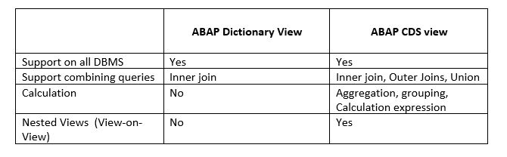

Q: **Difference between ABAP CDS and HANA CDS?**

A:

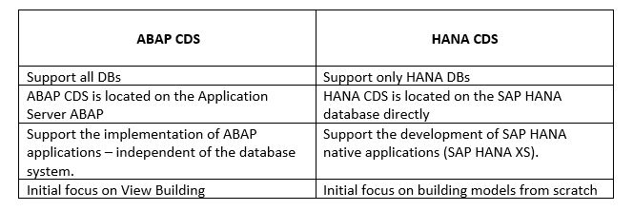

Q: **How do you define a CDS View in SAP?**

A: A CDS View is defined using a DDL (Data Definition Language) statement in the ABAP Development Tools (ADT) or SAP HANA Studio. The statement defines the view name, data fields, and other attributes, such as filtering and sorting criteria.

Q:**What is a CDS extension?**

A: CDS extensions are used to enhance existing CDS views by adding additional fields or annotations. They allow developers to modify the behavior of CDS views without having to create a new view from scratch.

Q:**What is Associations? How it is different from Join?**

A: An association defines relationship entities. An association associates the current CDS view as a source data source with the target data source target using an ON condition.

Although associations and joins look diﬀerent, there is no diﬀerence on the database level. Eventually, any association is translated into an ordinary join. But in the case of so-called exposed associations, it depends on the way a view is consumed. The join is only executed if the consumer requests data from the associated data source. This can have a positive effect on the performance and sometimes is referred to as “JOIN on Demand”.

Associations may contain additional semantic information such as cardinality.

Q:**What are the types of associations?**

A:

* Ad-hoc association
* Exposed association
* Filtered association.

Q:**What is Union and union all?**

A: UNION joins the result sets of two queries.

The rows of the result set of the query after UNION are inserted into the result set of the query before UNION.

If the addition ALL is not speciﬁed, all duplicate entries are removed from the results set. They are not removed if ALL is speciﬁed.

Q:**How CDS view and SQL view are related?**

A: A CDS View is deﬁned in a DDL Source, which is a new type of repository object.

Upon activation of a DDL Source, two objects are created: the SQL View and the CDS View.

The SQL View is visible as an object in the ABAP Dictionary where it cannot be edited and only reveals a fraction of the information available in the DDL source. It serves as a representative of the database object.

The CDS View carries more semantics than its SQL view. It is not created on the Database and it is not visible in the ABAP Dictionary. It can, however, be consumed via open SQL.

Q:**What is the use of Annotation?**

A: Annotations enrich the CDS definition with metadata.

It starts with character @.

The annotation specifies the properties and semantics of an entity and its​​ behavior when it is consumed.​​

Q: **What is the cardinality in an association?**

A: Cardinality in an association represents the number of occurrences of an entity that can be associated with another entity. The possible values for cardinality are:

* **[0..1]**: zero or one occurrence of the entity can be associated with the current entity.
* **[1]**: exactly one occurrence of the entity can be associated with the current entity.
* **[0..n]**: zero to many occurrences of the entity can be associated with the current entity.
* **[1..n]**: one to many occurrences of the entity can be associated with the current entity